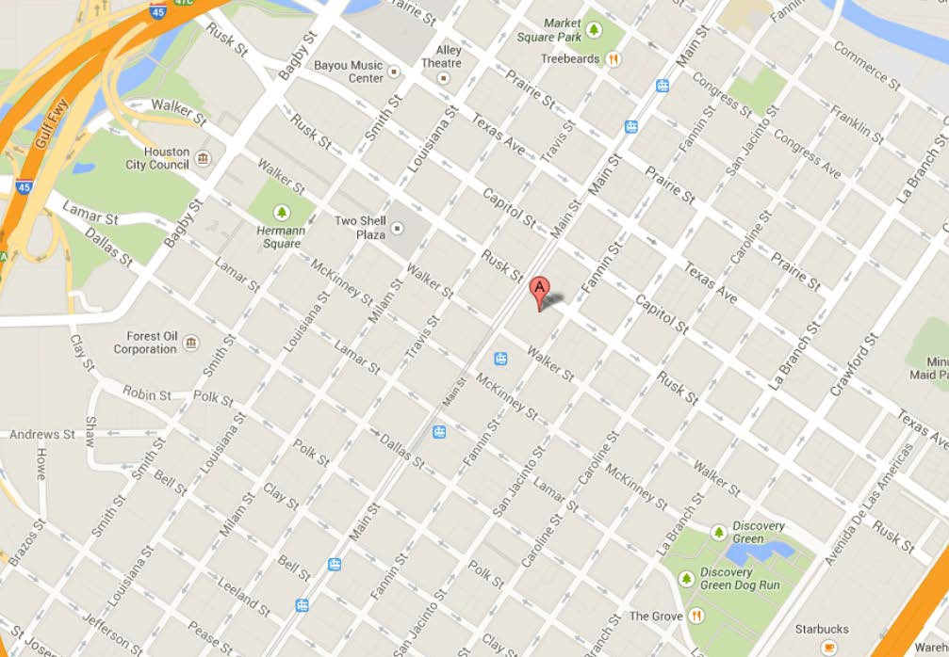

Directions from Houston Intercontinental Airport to the office:
As you leave the airport, travel south on I-59 to Exit N610 to I-45 south. Follow I-45 south to the McKinney Street exit. Follow McKinney Street to Travis and turn left. Follow Travis to Rusk, turn right on Rusk and right on Fannin. Visitor parking garage entrance is on Fannin.

Directions from the Houston Hobby Airport to the office:
As you leave the airport, travel north on I-45, take exit 45 toward Scott St. Keep left at the fork, follow signs for St. Joseph Parkway and merge onto St. Joseph Parkway. Turn right on San Jacinto St., left onto Capitol and left on Fannin. Visitor parking garage entrance is on Fannin.

